ASSIGNMENT – 04
- List 3 key differences between Ethernet cables and fiber optic cables, and give one real-world example where each type would be used (for example, home WiFi router, data center, college campus backbone).

Point | Ethernet Cable | Fiber Optic Cable
1. Transmission | Uses electrical signals to transfer data. | Uses light signals to transfer data.
2. Distance | Best for shorter distances, usually within a building. | Suitable for long distances with less signal loss.
3. Cost | Cheaper and easier to install. | More expensive and requires specialized tools.

- Draw and label a diagram showing the internal wiring of a straight-through Ethernet cable (use T568B wiring standard), indicating the color of each wire and its pin number

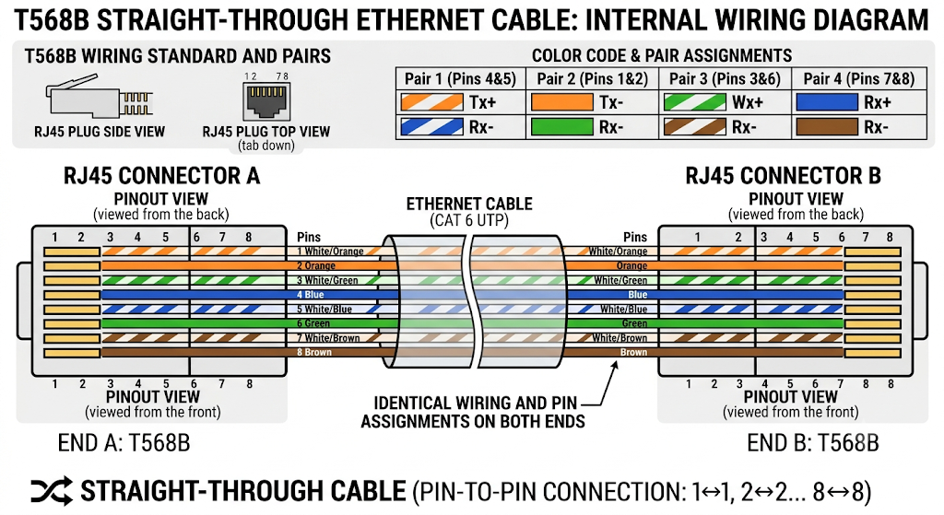

- Watch a YouTube video demonstrating how to use an RJ45 crimper, then write a step-by-step guide (in your own words) on how to attach an RJ45 connector to a CAT6 cable.

- Take a CAT6 cable and an RJ45 connector.
- Cut the cable to the required length using a cable cutter.
- Remove about 2–3 cm of the outer jacket from one end of the CAT6 cable.
- Separate the 8 colored wires inside the cable.
- Arrange the wires according to the T568B color standard:
  - White-Orange
  - Orange
  - White-Green
  - Blue
  - White-Blue
  - Green
  - White-Brown
  - Brown
- Straighten the wires and keep them tightly together in the correct order.
- Trim the wire ends evenly so they are the same length.
- Insert all 8 wires into the RJ45 connector, making sure each wire reaches the end.
- Check the colour order through the transparent RJ45 connector.
- Place the RJ45 connector into the crimping tool.
- Squeeze the RJ45 crimper firmly to lock the connector onto the cable.
- Check the finished connector to make sure it is properly attached.
- Repeat the same process on the other end of the cable if you need an Ethernet cable with connectors on both ends.
- Test the cable using an Ethernet cable tester to confirm all connections are working.
s

- Imagine you are setting up a gaming café with 10 PCs for LAN gaming. Decide which cable type (Ethernet or fiber optics) and which tool (RJ45 crimper or fiber cleaver) you would use, and explain your choices in 3-4 sentences.<br><br><em><strong>Hint:</strong> Consider speed, distance, and budget for your answer.</em>

- Cable Type: Use Ethernet (Cat6) cable.
- Reason: Cat6 provides good speed and low latency, which is important for LAN gaming.
- Distance: It is suitable for short distances inside a gaming café.
- Budget: Ethernet is cheaper and easier to install than fiber optics.
- Tool: Use an RJ45 crimper to attach RJ45 connectors to the Ethernet cables.
- Fiber Optics: Fiber and a fiber cleaver are more suitable for long-distance and high-speed connections.

